1)
CREATE DATABASE company;
USE company;
CREATE TABLE Empl (
empno INT PRIMARY KEY,
ename VARCHAR(50),
job VARCHAR(50),
mgr INT,
hiredate DATE,
sal DECIMAL(10,2),
comm DECIMAL(10,2),
deptno INT
);
INSERT INTO Empl VALUES (8369, 'SMITH', 'CLERK', 8698, '1990-12-18', 800.00, NULL, 20);
INSERT INTO Empl VALUES (8499, 'ANYA', 'SALESMAN', 8698, '1991-02-20', 1600.00, 300.00, 30);
INSERT INTO Empl VALUES (8521, 'SETH', 'SALESMAN', 8698, '1991-02-22', 1250.00, 500.00, 30);
INSERT INTO Empl VALUES (8566, 'MAHADEVAN', 'MANAGER', 8839, '1991-04-02', 2985.00, NULL, 20);
INSERT INTO Empl VALUES (8654, 'MOMIN', 'SALESMAN', 8698, '1991-09-28', 1250.00, 1400.00,30);
INSERT INTO Empl VALUES (8698, 'ΒΙΝΑ', 'MANAGER', 8839, '1991-05-01', 2850.00, NULL, 30);
INSERT INTO Empl VALUES (8882, 'SHIVANSH', 'MANAGER', 8839, '1991-06-09', 2450.00, NULL, 10);
INSERT INTO Empl VALUES (8888, 'SCOTT', 'ANALYST', 8566, '1992-12-09', 3000.00, NULL, 20);
INSERT INTO Empl VALUES (8839, 'AMIR', 'PRESIDENT',NULL, '1991-11-18', 5000.00, NULL, 10);
INSERT INTO Empl VALUES (8844, 'KULDEEP', 'SALESMAN', 8698, '1991-09-08', 1500.00, 0.00, 30);

SELECT * FROM Empl
ORDER BY empno;
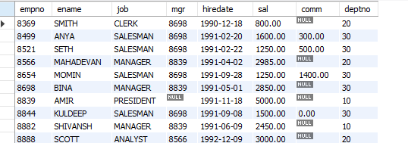

SELECT ename, sal FROM Empl WHERE sal >= 2200;
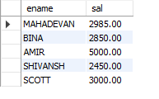

SELECT * FROM Empl WHERE comm IS NULL;
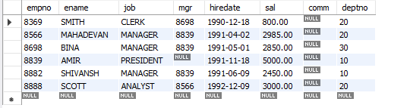

SELECT ename, sal FROM Empl WHERE sal NOT BETWEEN 2500 AND 4000;
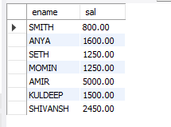

SELECT ename, job, sal FROM Empl WHERE mgr IS NULL;
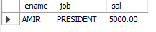

SELECT ename FROM Empl WHERE ename LIKE '-_A%';

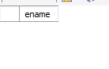

SELECT ename FROM Empl WHERE ename LIKE '%T';
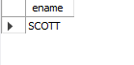

2)
use company;

CREATE TABLE employee (
empcode INT PRIMARY KEY,
empname VARCHAR(50),
empage INT,
esalary DOUBLE
);

Java code for jdbc
import java.sql.*;
public class EmployeeInsert {
public static void main(String[] args) {
String url = "jdbc:mysql://localhost:3306/company"; // DB name
String user = "root"; // MySQL username
String password = "2gowtham8"; // MySQL password
String insertQuery = "INSERT INTO employee (empcode, empname, empage, esalary) VALUES (?, ?, ?, ?)";
// Sample employee data (use 10000.0 instead of 10000 to make them Double)
Object[][] employees = {
{101, "Jenny", 25, 10000.0},
{102, "Jacky", 30, 20000.0},
{103, "Joe", 20, 40000.0},
{104, "John", 40, 80000.0},
{105, "Shameer", 25, 90000.0}
};
try (Connection conn = DriverManager.getConnection(url, user, password);
PreparedStatement pstmt = conn.prepareStatement(insertQuery)) {
for (Object[] emp : employees) {
pstmt.setInt(1, (Integer) emp[0]);
pstmt.setString(2, (String) emp[1]);
pstmt.setInt(3, (Integer) emp[2]);
pstmt.setDouble(4, ((Number) emp[3]).doubleValue()); // Safe casting
pstmt.executeUpdate();
}
System.out.println("Data inserted successfully.");
} catch (SQLException e) {
e.printStackTrace();
}
}
}

SELECT * FROM employee;

